**Brooklyn torah gazette**

**For parshas bo 5783**

Volume 7, Issue 20 (Whole Number 327) 6 Shevat 5783/ January 28, 2023

**Printed L’illuy nishmas Nechama bas R’ Noach, a”h**

For a free subscription, please forward your request to [***keren18@juno.com***](mailto:keren18@juno.com)

Past stories can be found on the website **ShabbosStories.com**

**When A Prince Criticizes**

**His Family**

**By**[**Rabbi YY Rubinstein**](https://www.jewishpress.com/author/rabbi-yy-rubinstein/)

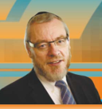

Photo Credit: Jewish Press

I recently posted about something on my Facebook page as I didn’t think I could ignore the fact that almost everyone was posting about it on theirs. It was about the publication of Prince Harry’s book “Spare”…

*“I have not read this book. I am not interested in doing so. I would, though, like to offer a humble reminder. Anyone coming to a conclusion or opinion about a dispute between two or more people without hearing both or all sides, is quite simply either a knave or a fool.”*

Leaving the book aside (after all, it wasn’t actually written by the Prince in any case) there is an important Jewish concept its publication raises.

In 2006 the antisemitic Iranian regime hosted a two-day conference in Tehran to discuss *whether* the Holocaust actually happened.

It drew 67 attendees from 30 countries like David Duke, ex Ku Klux Klan leader, and assorted convicted Holocaust deniers from Germany, France, England, Australia and more.

**Highlights from a Disgusting Conference**

A presenter from Sweden claimed that only 300,000 Jews had been killed, not six million. A notorious British Holocaust denier, Michele Renouf, explained that anyway, those Jews who did die at the hands of the Nazis, did so as a result of “Jewish Leaders.”

The Vatican condemned this obscene event as did the Bush administration. Tony Blair, the UK Prime Minister called it “shocking beyond belief.”

More shocking, was the attendance at the conference of six Orthodox Jews from Neturei Karta.

The leader of those six is someone I have known since he was the M.C. at my wedding to my late wife over forty years ago, long before he morphed into a Neturei Karta-nik.

Unsurprisingly, he became a pariah in the UK’s Manchester community where we both lived. Only one shul out of the hundreds in the burgeoning Hareidi community allowed him to attend, the rest banned him.

**My Turn to Respond to the Traitor**

Once when I was there learning with my son, he approached me and attempted to explain and defend his actions. After listening to his self-justification, it was my turn to respond.

This was not as easy to do as you might think. I remembered him from when I was a young man and he was a well-regarded member of Manchester’s Jewish community.

I began by saying that I didn’t mind in the slightest that he was not a Zionist or even that he was an anti-Zionist. He was certainly entitled to his opinion. Then I added, “But even if that is your position and you believe in both sincerely and passionately; You stand with your people… and you never shake hands with people who have Jewish blood dripping from them.”

The nineteenth century American Naval hero, Stephan Decatur is credited with coining the phrase. “My country right or wrong.” It has been much ridiculed and disparaged almost from the moment the words left his lips during an after-dinner toast. It was criticized as chauvinist and jingoist rather than merely patriotic, which he perhaps meant it to be.

Certainly, the saying is open to a benign interpretation; it doesn’t have to suggest and inspire over-patriotic fervor.

There is a noble tradition in the British Parliament that resonates with Decatur’s words. No criticism of an armed conflict is voiced while British soldiers are fighting and risking their lives for their country, even if individual parliamentarians may disapprove of the particular war.

**One of the Biggest Controversies**

**Surrounding the UK Chief Rabbi**

That tradition and custom helped frame one of the biggest controversies of Rabbi Sacks’s period as UK Chief Rabbi.

In 2002, he gave an interview to the UK’s Guardian newspaper which provoked a wave of fury across the Jewish world. In it, he said he was shocked at the behavior of Israeli soldiers after seeing a photograph purporting to show IDF soldiers posing beside a slain Palestinian. He also argued that Israel was adopting a stance, “incompatible” with the deepest ideals of Judaism, and that the current conflict with the Palestinians was “corrupting” Israeli culture.

Carl Schurz the 13th U.S. Secretary of the Interior took Stephan Decatur’s famous phrase and in a speech decades after the original, modified it so it became,

*“My country, right or wrong. If right, to be*kept*right; and if wrong, to be*set *right.”*

Rabbi Sack’s comments themselves were more Schurz than Decatur (his predecessor Lord Jacobovits also angered many when he too criticized Israel’s treatment of the Palestinians.)

What I suspect Rabbi Sacks was attempting to express and to do in his comments was to, “set his country right.”

**The Problem of Whom You Speak to**

It’s not then what he said, but where and to whom he said it that was the problem. The Guardian, a doppelganger of the New York Times, has a long and ignoble history of extreme anti-Israel bias. Many British Jews would say that it has long since crossed the line into antisemitic bias.

And that takes us back to Prince Harry and his book. There is no denying from even his staunchest supporters that it is full of negative accusations and damning claims about his father, step-mother, brother, sister-in-Law and even grandmother, the late Queen Elizabeth, which he has announced to the world.

And that in turn takes us to that important Jewish concept I mentioned at the beginning and another famous anti-Zionist.

Rabbi Yoel Teitelbaum, Rebbe of Satmar was well known for his opposition to Zionism. On one occasion he was visited by the famous speaker of the House of Representatives, “Tip” O’Neil. His aides had briefed him about the Rebbe’s position on Israel and so during the meeting, the Speaker made critical comments about the Jewish State. When he did so, the Rebbe launched a staunch defense of the Israeli State and its people.

Afterwards, he was challenged by his *Chassidim* for his inexplicable advocacy of something he was in fact fearlessly critical of. He explained, “That is a disagreement *within* a family. You do not take family disagreements *outside* the family.”

And I would add, under no circumstances do you *ever* take them to the enemies of *Am Yisrael*.

*Reprinted from the January 19, 2023 website of the Jewish Press.*

**Rav Avigdor Miller on**

**Taking the Blame**

**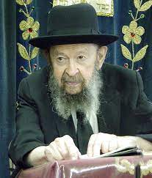**

**QUESTION:** **The Rav said tonight that when someone gets sick or hurt, he shouldn’t blame Hashem, but he should look to blame himself for not taking care of himself properly. But shouldn’t we be looking back to see which sins we did to cause Hashem to punish us with the cold or the virus or whatever it is?**

**ANSWER:** Absolutely. Absolutely! יפשפש במעשיו. He must search out his deeds. אם רואה אדם שיסורין באין עליו יפשפש במעשיו – If a person sees that troubles are coming upon him, he should search out his ways and his deeds (Brachos 5a). But among the פשפוש that he searches should be, “What did I do to neglect my health? Am I getting enough sleep? Am I dressed warmly? Am I eating properly? Am I careful when I cross the street?”

You shouldn’t neglect those sins either. A person is responsible to take care of himself. Hashem says, “I gave you a body and you have no right to neglect it.” So while you’re searching out your deeds remember that this as well is a very important subject to look for. Because often you are the cause of your sickness because you don’t take care of yourself. And that’s also a sin against Hashem. 

*Reprinted from the January 19, 2023 email of Toras Avigdor (Tape #E-172 – May 1999).*

**The Mesirat Nefesh Aspect of**

**The Original Passover Offering**

**From the Teachings of the Lubavitcher Rebbe**

**Rabbi Menachem Mendel Schneerson, Zt”l**

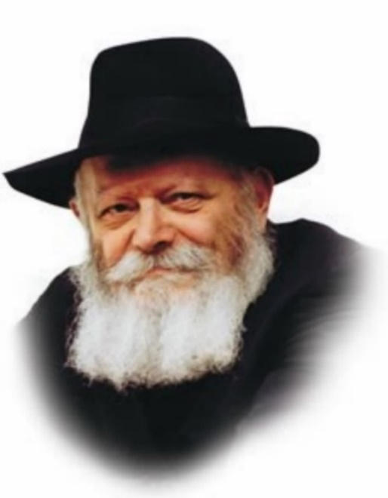

This week's Torah portion, Bo, enumerates the details of the Passover offering. The lamb had to be selected, watched for four days, slaughtered, and then eaten roasted with matzot and bitter herbs.

In his Sefer Hamitzvot, Maimonides counts the mitzva of the Passover offering as two separate commandments: 1) slaughtering the lamb at dusk on the 14th of Nisan, and 2) eating it on the night of the 15th.

**Two Connected and Interdependent Mitzvot**

These two mitzvot are connected to each other and interdependent. Thus, at first glance, it is not clear why Maimonides counts them as two separate commandments.

The exodus from Egypt was a pivotal event for the Jewish people, as it was then that they were born as a nation. No longer were they slaves to Pharaoh; instead, they were transformed into the servants of G-d.

The purpose of the Passover offering was to prepare the Jews for the exodus. Every detail was significant, for each one readied them in a different way for the great event.

Precisely because it is so fundamental, the mitzva of the Passover offering is reckoned as two separate commandments: the sacrifice itself, and the eating of it. Both particulars were required to prepare for the departure from Egypt and the Jews' transformation into servants of G-d.

In ancient Egypt the lamb was worshipped as a deity. By offering it as a sacrifice, the Jewish people shook off their yoke of subjugation. It took a great deal of mesirat nefesh (self-sacrifice) for the Jews to publicly take that lamb and kill it in front of their horrified neighbors. But in order to be a true servant of G-d, self-sacrifice is necessary. This was the mitzva of slaughtering the Pesach offering.

**Sacrificed with Meirat Nefesh**

The second mitzva was to actually eat the lamb. When a Jew ate the Passover offering, which had been sacrificed with mesirat nefesh, its flesh was transformed into his own. The substance of the offering was digested and became one with his physical body. Self-sacrifice has to be the central theme in the life of the Jew; it must surround him, permeate his being and fill him completely, spilling over into the physical plane of his existence. In this manner, mesirat nefesh became part and parcel of the Jew's being, preparing him for the exodus from Egypt and enabling him to become a "servant of G-d."

*Reprinted from the Parshat Vayechi 5783 edition of L’Chaim (Issue #504) Adapted from Likutei Sichot, Volume 16.*

**Rabbi Berel Wein on**

**Parshas Bo 5783**

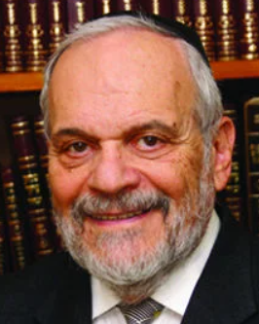

As the drama of the Exodus from Egypt draws nearer its climax in this week’s Torah reading, one cannot help but be struck by the stubbornness of Pharaoh in the face of all of the plagues visited upon him and his nation. His advisers had long before told him that all was lost and that he should cut his losses quickly by freeing the Jewish people from Egyptian slavery. This seemingly wise and rational counsel was rejected by Pharaoh out of hand.

Pharaoh sees himself as a godlike figure, omniscient, supremely brilliant and all knowing. He is trapped in a propaganda web of his own making – he can never admit to being wrong or to having made an error of judgment or policy. In the course of human history this has often been the fatal error made by dictators who were always supremely confident in their arrogance and who never acknowledged their mistakes.

Just recall the mass murderers and dictators of our past century – Hitler, Stalin, Mao, Pol Pot, Arafat, etc. None of them ever admitted to error and all of them led their people to disaster and untold suffering. This was the arrogance of power overwhelming rational thought and nullifying good strategic planning. There is also an arrogance of intellect. The intellectuals amongst us, who always know what is best for everyone else, are never reticent about rendering opinions on all issues and policies.  Again, the fact that they have been wrong – dead wrong – so many times in the past causes them no inhibition in advancing their current viewpoints.

The Torah seems to attribute Pharaoh’s continuing folly of unreasonable stubbornness, to G-d, so to speak, ‘hardening his heart.’ This implies that somehow Pharaoh’s freedom of choice was diminished and he could not have capitulated to the demands of Moshe even if he had wished to do so. This philosophic and theological difficulty has been dealt with by the great commentators of Israel over the ages, with varying theories offered and advanced.

It seems from many of their opinions that at a certain point in human decision- making, a tipping point is achieved when the leader can no longer admit to error and remain the leader. ‘Hardening’ the leader’s heart means there is an unwillingness to give up one’s position of power. Very few leaders in the history of humanity have willingly surrendered power.

Simply rising to a position of leadership, let alone absolute and dictatorial power, almost automatically ‘hardens one’s heart’ and limits one’s choices and policy options. The Torah blesses a generation that is privileged to have a leader that is capable of admitting sin and error and can offer a public sacrifice in the Temple in atonement.

The greatness of King David lies not only in his heroic spiritual and physical accomplishments as king of Israel but in his ability to admit to personal failings and errors of judgment. Pharaoh is incapable of such self-scrutiny and realistic humility. His lust for power has ‘hardened his heart’ beyond the power of recall. He has doomed himself as have so many of his ilk over the centuries.

Shabbat shalom

*Reprinted from this week’s website of rabbiwein.com*

**Thoughts that Count**

*And there was a thick darkness in all of Egypt for three days* (Exod. 10:22)

The plague of darkness lasted for six days, three days of darkness when no one was able to see anyone else, and "a thick darkness... for three days" which was so dense that the Egyptians were unable to move. All of the other plagues (aside from the death of the first-born which lasted only one day) were seven days long. G-d saved the last day of darkness for when the Egyptians chased after the Jews in the desert. When the Jews travelled at night they were guided by a pillar of fire, but when the Egyptians chased them, G-d punished the Egyptians by causing them to travel in darkness. *(Midrash Raba)*

*And G-d said to Moses and Aaron..."This month shall be for you the head of the months."* (Exod. 12:1-2)

The Jewish calendar follows the lunar system. The solar calendar is 365 days, and the lunar calendar is approximately 354 days. To make up for the deficiency, seven years in every 19-year cycle are leap years. Thus, in some years, the lunar year is actually a few days ahead of the solar year. The leap year serves as a reminder that everyone has an opportunity to make up for what he has failed to accomplish in the past. Furthermore, just as the leap year not only makes up for the deficiency, but provides an "advance" on the future, a Jew must also intensify his efforts in his service of G-d and store up additional merits. *(Likutei Sichot)*

*And he called for Moses and Aaron at night and he said, "Rise up, go out from among my people."* (Exod. 12:31)

When Moses approached Pharaoh after the plague of darkness, Pharaoh angrily said to him, "I am warning you not to see my face anymore, because on the day when you will see my face you will die." Thereafter Moses didn't return to Pharaoh. After the plague of the firstborn Pharaoh summoned Moses but Moses refused to come because Pharaoh had said Moses would die if he saw his face again. Pharaoh, knowing that he needed to see Moses, began to plead, "Now it is night. Since it is dark and hard to see my face, please come speak to me and take the Jewish people out of my country." *(Or Hachaim)*

*Reprinted from the Parshat Vayechi 5783 edition of L’Chaim (Issue #504) Adapted from Vedibarta Bam by Rabbi Moshe Bogomilsky*

**The Legacy of Rav**

**Eliyahu Guttmacher**

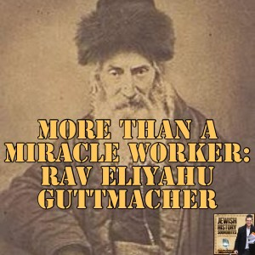

R' Eliyahu Guttmacher was born near Posen (Poznan) in eastern Germany (today, Poland) on Rosh Chodesh Av 5556 / 1796. After studying in the yeshiva of Rawicz, he became, at age 19, a student of R' Akiva Eger, rabbi of Posen. He remained in R' Eger's yeshiva for four years and was a favorite of the teacher.

Even as a youth, R' Guttmacher studied assiduously and remained awake late into the night writing down his Torah insights. A turning point in his life occurred when he discovered a copy of the Zohar with the marginal notes of his teacher, R' Eger.

R'Guttmacher had previously believed, as did most people, that R' Eger was opposed to the study of Kabbalah. However, upon realizing that his teacher did, indeed, delve into that subject, the student began his own study of Kabbalah. As an outgrowth of this study, R' Guttmacher began to reflect upon the causes of our exile and the steps that we can, and must, take to end it.

He came to believe that the spiritual state of the Jewish people was declining rapidly and it was necessary to force the arrival of mashiach, something that could be achieved only if the Jewish people strengthened their attachment to Torah and returned to Eretz Yisrael.

He strongly encouraged the establishment of both yeshivot and farming communities in the Holy Land, and when most leading rabbis either did not support his call (and many openly opposed it), he declared that the Satan / the prosecuting angel had blinded them in order to delay the Redemption.

R' Guttmacher's study of Kabbalah also drew him close to the chassidic movement, and, in time, he was surrounded by chassidim of his own. He tried to discourage people from seeking his blessings, saying that he was merely an ordinary person. R' Guttmacher also said that just in case his prayers carried any weight in Heaven, he was already praying for all Jews; therefore, there was no need to visit him.

However, all of his efforts to be left alone were futile. R' Guttmacher published several pamphlets describing his ideas about the Redemption and the return to Eretz Yisrael. He also left behind many manuscripts on "traditional" Torah subjects, and some of his commentaries are published in the back of the standard Vilna edition of the Talmud. (Some of his larger works were first published in the 1970's and 80's.)

He also kept a diary, which he closed with the words: "I am leaving for my world [i.e., Olam Haba] comforted that the Shechinah pines for those who love it. I feel that the three-part cord - the Torah, the Holy One, blessed is He, and Yisrael - is in the process of being tied again." (Encyclopedia La'chassidus).

*Reprinted from the Parshat Bo 5783 email of R’ Yedidye Hirtenfeld’s whY I Matter parsha sheet for the Young Israel of Midwood in Brooklyn, NY.*

**The Fascinating History of Coffee and the Jews**

**By**[**Yehuda Shurpin**](https://www.chabad.org/search/keyword_cdo/kid/15169/jewish/Shurpin-Yehuda.htm)

Coffee originated in the Ethiopian highlands and then spread east to the Arabian peninsula. But it was not until around the 15th century that roasted coffee beans, and the beverage made out of them, became popular.

In those days, coffee was not brewed at home but rather in coffeehouses, which were springing up everywhere. By the 17th century, coffee had made its way to Europe and had become popular across the continent as well as in the New World.

Jews, too, became very involved in the coffee trade. In fact, according to some historians, coffee was first introduced in England by a Jew named Jacob, who opened a coffeehouse in Oxford in 1650.[1](javascript:doFootnote('1a5776631');) This drink was so strongly associated with the Jewish people that the chief rabbi of Egypt, Rabbi Avraham ben Dovid Yitzchaki (1661–1729), referred to it as the “Jewish beverage.”[2](javascript:doFootnote('2a5776631');)

**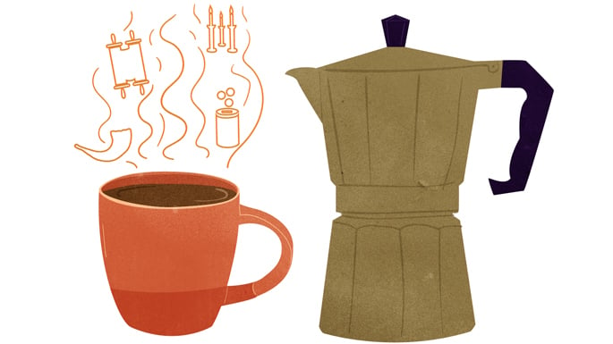**

***Art by***[***Sefira Lightstone***](https://www.chabad.org/3159160)

Paralleling the spread and popularity of coffee, many fascinating halachic questions arose regarding this beverage. The following are just some of the halachic issues concerning coffee.

**Cooked By Jews**

The very first recorded responsum addressing coffee seems to be from Rabbi David ibn Zimra (the Radbaz, c.1479–1589), the leading rabbi in Egypt and later in Safed, Israel.

There is a halachic principle that Jews may only eat food cooked by fellow Jews, known as *[bishul Yisrael](https://www.chabad.org/library/article_cdo/aid/947606/jewish/Laws-of-Bishul-Yisrael.htm" \o "Laws of Bishul Yisrael)*. Now, this does not apply to foods that are either ordinarily eaten raw or are inferior and not “fit to be served at a king's table.”

Thus, the question was asked: Is coffee a royal beverage and therefore only kosher if cooked by a Jew?

The Radbaz started off his responsum[3](javascript:doFootnote('3a5776631');) by explaining that he researched coffee and came to the conclusion that it was indeed served at the tables of kings and ministers and never consumed raw.

Nevertheless, he ultimately ruled that there was no concern of *bishul Yisrael*concerning coffee. This issue was further discussed by rabbis of subsequent generations and most concurred with his ruling. One of the main reasons given is that coffee mostly consists of water and is not a food.[4](javascript:doFootnote('4a5776631');) There are, however, some who are strict and refrain from drinking coffee brewed by a non-Jew.[5](javascript:doFootnote('5a5776631');)

This leads us to another question regarding coffee.

**What Blessing Is Said?**

Generally, if one cooks fruits or vegetables in a liquid, the blessing on the liquid would be the same as the blessing made over the fruit or vegetable. Since coffee beans grow on a tree, the question arose whether one should make the blessing of *Ha’etz* before coffee, just as one would do before enjoying a tree fruit.

In the final analysis, however, the blessing over coffee is *Shehakol*. One reason for this is that the above-mentioned rule only applies when the fruit is cooked with the intent of consuming it together with the liquid, such as a fruit compote.

In this case, however, the beverage is never enjoyed together with the coffee beans and therefore becomes a separate item with a separate blessing.[6](javascript:doFootnote('6a5776631');)

**After-Blessing Following a Hot Drink**

Although we recite a blessing before eating or drinking any amount, when it comes to making an after-blessing *(berachah acharonah)*, one must eat or drink a specific quantity in a specific time frame. Now, when it comes to food, this is generally not too difficult since the time frame is to eat food equal to the size of an olive in about 3-4 minutes (this time frame is known as *bichdei achilat peras*). However, according to many, the time frame for beverages is to drink a *revi’it* (approx. 3 oz.) in the time it takes to normally drink that amount of liquid (30 seconds or even less). As such, this rule would pose a difficulty when it comes to hot beverages such as coffee, which are usually sipped slowly.[7](javascript:doFootnote('7a5776631');)

Indeed, there are some who rule that if you just sipped the hot beverage and didn’t consume it in the very short time frame, you would not make an after-blessing.[8](javascript:doFootnote('8a5776631');) Others suggest leaving the last three ounces of coffee in your cup and, once it’s cooled off a bit, drinking it in one shot.[9](javascript:doFootnote('9a5776631');)

However, Rabbi Shneur Zalman of Liadi[10](javascript:doFootnote('10a5776631');) rules that in terms of making an after-blessing, liquids have the same time frame as solid foods (*bichdei achilat peras).*So as long as you drank the required amount in that time frame, you would still make a blessing after sipping your coffee.

**Coffee With Non-Jews**

As coffee and coffeehouses became popular, another concern arose.

As a rule, the rabbis forbid drinking beer and other alcoholic beverages in places frequented by non-Jews (such as in their bars or homes) due to the concern that this can lead to intermarriage.

Does this enactment apply to a common coffeehouse as well?

Ultimately, many authorities are lenient for multiple reasons, including the argument that the enactment only applies to intoxicants.[11](javascript:doFootnote('11a5776631');) However, they caution that a pious person should take care not to frequent non-Jewish coffeehouses, at least not regularly.[12](javascript:doFootnote('12a5776631');)

**Making Coffee on Shabbat**

With the advent of home-brewed coffee, the issue arose as to whether coffee may be brewed on Shabbat.

It is clear that grinding beans and cooking are forbidden. Generally speaking, once water has been poured from the urn into a second vessel and from there into a third vessel, it has cooled to the point where it is not hot enough to cook.

As such, when using instant coffee, one should pour hot water from the urn (which has been on since before Shabbat began) into a dry cup, and from there into a second dry cup, where it is mixed with the coffee (and milk and sweetener).[13](javascript:doFootnote('13a5776631');)

When using the pour-over method, one would do the same: Pour the water into a dry cup, and from that cup, pour the water over the grinds.

French presses, timers and other methods of coffee making are beyond the scope of this article.

**Kashrut of Coffee**

Plain, black, unflavored coffee is essentially [kosher](https://www.chabad.org/library/article_cdo/aid/113424/jewish/Kosher.htm) as long as one can ascertain that no milk, creamer or flavor was added. Additionally, the utensils used to make the coffee cannot have been used to make other non-kosher foods or beverages.

(Interestingly, this issue is addressed in the very first responsum about coffee cited earlier. The conclusion was that the pots used to roast and make the coffee were used exclusively for coffee and posed no concern, but much has changed since then.)

**Coffee on Passover**

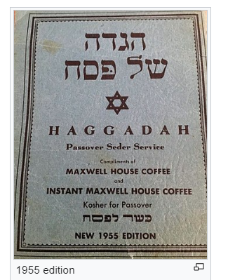

Since it is the custom of Ashkenazi Jewry to avoid the consumption of *kitniyot*(certain beans and legumes) on [Passover](https://www.chabad.org/holidays/passover/default_cdo/jewish/Passover.htm), the question arose as to whether coffee falls under this category.

Some halachic authorities mistakenly thought that coffee beans were actual beans. In fact, coffee beans are the seeds of a cherry-like fruit, and there isn’t an issue of [*kitniyot*](https://www.chabad.org/holidays/passover/pesach_cdo/aid/871998/jewish/Kitniyot-on-Passover-Is-It-Allowed.htm).[14](javascript:doFootnote('14a5776631');)

Nevertheless, there were some who were strict and would only drink coffee that had been ground before the holiday. They feared that since coffee is referred to as a “bean,” people would assume that bona fide beans are permitted on Passover.[15](javascript:doFootnote('15a5776631');)

According to all, coffee enjoyed on Passover must be free of *chametz*. This is particularly an issue with regard to decaffeinated coffee, which is often processed with ethyl acetate, which can be derived from [*chametz*](https://www.chabad.org/holidays/passover/pesach_cdo/aid/1601/jewish/Getting-Rid-of-Chametz-Step-by-Step.htm). Thus, decaf coffee must bear a kosher-for-Passover certification in order to be used on Passover.

**FOOTNOTES**

[1.](https://www.chabad.org/library/article_cdo/aid/5776631/jewish/The-Fascinating-History-of-Coffee-and-the-Jews.htm" \l "footnoteRef1a5776631) Brian Cowan, *The Social Life of Coffee* (Yale University Press, 2005), p. 90.

[2.](https://www.chabad.org/library/article_cdo/aid/5776631/jewish/The-Fascinating-History-of-Coffee-and-the-Jews.htm" \l "footnoteRef2a5776631) Responsa *[Zera Avraham,](http://chabadlibrarybooks.com/pdfpager.aspx?req=843&pgnum=6" \t "_blank)*[Orach Chaim 2](http://chabadlibrarybooks.com/pdfpager.aspx?req=843&pgnum=6" \t "_blank).

[3.](https://www.chabad.org/library/article_cdo/aid/5776631/jewish/The-Fascinating-History-of-Coffee-and-the-Jews.htm" \l "footnoteRef3a5776631) *Teshuvot HaRadbaz* 3:1062(637).

[4.](https://www.chabad.org/library/article_cdo/aid/5776631/jewish/The-Fascinating-History-of-Coffee-and-the-Jews.htm" \l "footnoteRef4a5776631) See *Peri Chodash*, *Yoreh De’ah*114:6; *Aruch Hashulchan, Yoreh De’ah*113:22-23; *Chelkat Binyamin* 113.

[5.](https://www.chabad.org/library/article_cdo/aid/5776631/jewish/The-Fascinating-History-of-Coffee-and-the-Jews.htm" \l "footnoteRef5a5776631)See *Shiurei Berachah (Chida)*113, regarding the practice of the Arizal; Responsa *Shevet Halevi* 5:93.

[6.](https://www.chabad.org/library/article_cdo/aid/5776631/jewish/The-Fascinating-History-of-Coffee-and-the-Jews.htm" \l "footnoteRef6a5776631) See*Seder Birkat HaNehenin*7:14.

[7.](https://www.chabad.org/library/article_cdo/aid/5776631/jewish/The-Fascinating-History-of-Coffee-and-the-Jews.htm" \l "footnoteRef7a5776631) See, for example, *Luach Birkat HaNehenin*2:7.

[8.](https://www.chabad.org/library/article_cdo/aid/5776631/jewish/The-Fascinating-History-of-Coffee-and-the-Jews.htm" \l "footnoteRef8a5776631) See *Birkei Yosef* 204:5; *Kitzur Shulchan Aruch*51:6; *Mishnah Berurah* 210:1.

[9.](https://www.chabad.org/library/article_cdo/aid/5776631/jewish/The-Fascinating-History-of-Coffee-and-the-Jews.htm" \l "footnoteRef9a5776631) *Be’er Heitev*204:12; *Mishnah Berurah* 210:1.

[10.](https://www.chabad.org/library/article_cdo/aid/5776631/jewish/The-Fascinating-History-of-Coffee-and-the-Jews.htm" \l "footnoteRef10a5776631) *Seder Birkat HaNehenin*8:6 and *She’erit Yehudah, Orach Chaim* 15 for an explanation on why he changed his mind in *Seder Birkat HaNehenin*. See, however, *Luach Birkat HaNehenin*2:7, which was composed at an earlier date, in which he writes that there is a disagreement whether there is a different measurement for liquids and therefore the *halachah* is that “when there is a doubt about a blessing we are lenient, and no [after-blessing] is made.”

[11.](https://www.chabad.org/library/article_cdo/aid/5776631/jewish/The-Fascinating-History-of-Coffee-and-the-Jews.htm" \l "footnoteRef11a5776631) *Birkei Yosef (Shiurei Berachah), Yoreh De’ah*113:3; *Chochmat Adam* 66:14.

[12.](https://www.chabad.org/library/article_cdo/aid/5776631/jewish/The-Fascinating-History-of-Coffee-and-the-Jews.htm" \l "footnoteRef12a5776631) See, for example,*Pitchei Teshuvah, Yoreh De’ah*114:1.

[13.](https://www.chabad.org/library/article_cdo/aid/5776631/jewish/The-Fascinating-History-of-Coffee-and-the-Jews.htm" \l "footnoteRef13a5776631) See *Shabbat KeHalachah,* vol. 1, ch. 7:2. There are opinions that allow instant coffee to be added to the second vessel*.* However, it is preferable to use the third.

[14.](https://www.chabad.org/library/article_cdo/aid/5776631/jewish/The-Fascinating-History-of-Coffee-and-the-Jews.htm" \l "footnoteRef14a5776631) See*Chida, Tov Ayin,* ch. 9.

[15.](https://www.chabad.org/library/article_cdo/aid/5776631/jewish/The-Fascinating-History-of-Coffee-and-the-Jews.htm" \l "footnoteRef15a5776631) See *Shaarei Teshuvah, Orach Chaim* 453:1.

*Reprinted from the Parshat Bo 5783 website of Chabad.org*